**602 – Final Project – Alexa Echo Skill**

**Introduction:**

Alexa echo is a smart speaker developed by Amazon. It takes natural language speech input and provides an output in speech format. It has a skills marketplace which provides and option to enable the specific skills.

For this project, I am planning to create an chatbot alexa skill in phases. IT service desk tickets dataset will be used in background for this skill. Skill also provides an functionality to interact with the dataset using AWS Lambda function.

**Description:**

Skills are the basic part of Alexa which works just like apps in android or ios phones. All the specific conversations and work are made via skills. New custom skills can be developed using different languages Node.js, Java, Python, or C#. For this project, I am going to develop using python. Within python, there is a micro-level framework called Flask(<http://flask.pocoo.org>). Flask-ask(<https://flask-ask.readthedocs.io/en/latest>) is the rapid alexa skills kit development.

I would like to create a chatbot with alexa in phases.

**Phase 1:**

1. Create a Flask-Ask environment with ngrok. By using ngrok(<https://ngrok.com>), we can test the skill without deploying into actual environment.
2. Create a space for storing the tickets data in amazon s3 bucket. Below is the snapshot of the dataset.

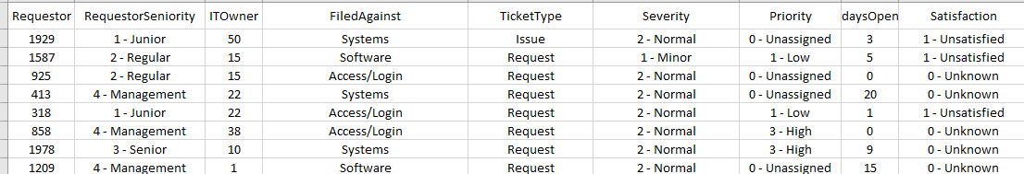

1. Develop the speech templates and utterances to interact with alexa via skill.
2. Here the answers will be calculated and filtered based on the questions which are asked.  
   For Eg,
   1. How many tickets have the satisfaction unknown?
   2. How many tickets are opened more than 10 days?
   3. Who is the IT owner of requestor 1929?
3. Alexa will perform the NLP and convert the sentence into question. Converted question is compared with the pre-defined sentence and return the output.

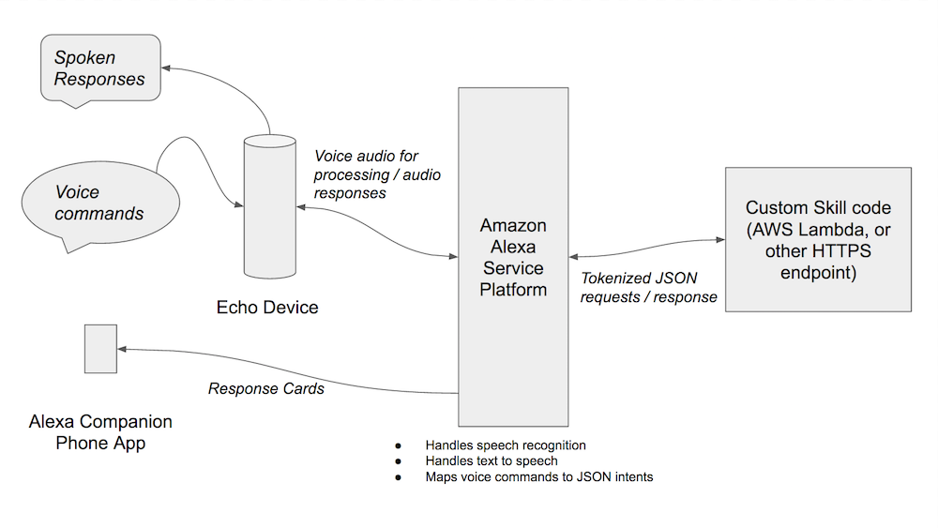

**Phase 2:**

Build conversational interface with amazon lex (<https://aws.amazon.com/lex>). This is the framework provided by amazon. Below is the sample code with advanced skill using lex.

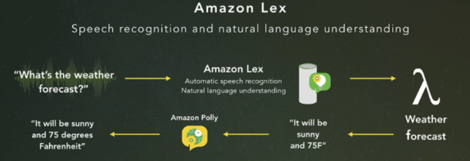

1. Create and configure amazon lex and s3 bucket.
2. Create an amazon lambda function for the background using aws python called boto (<https://github.com/boto/boto3#quick-start>)
3. Create an intend of this skill. For this project, intend is to forecasted tickets on upcoming dates and raise a new ticket. Below is the sample conversation in lex.

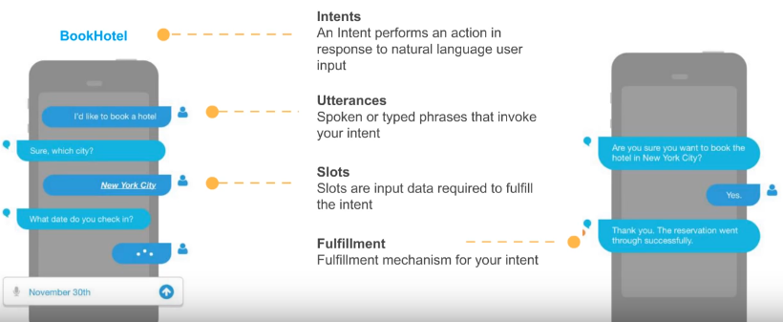

1. Some utterances for this project will be
   1. Raise a new ticket for login issue.
   2. What is the forecasted number of tickets in next week?
   3. Update my ticket #1 satisfaction rating to unsatisfied.

Lex also groups and predicts the intents with similar words.

1. Lex will respond to the utterances and update the record set in s3 bucket.
2. As an add-on, I am planning to deploy the chatbot in Facebook messenger.

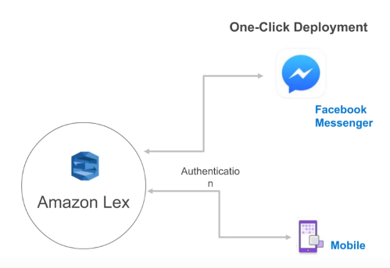

**Phase 3(Optional):**

Integrate Lex, AWS lambda with tensorflow to create an automated chatbot. So the data can scale in production environment. Tensorflow is good at deep neural networks. It can respond the bot with previous history of data.

Below is the high-level design of integrating Tensorflow. This is an optional phase which will be completed after first two phases.

